Online quiz website
By
Mohammed ismail P - 140282602039
Noor Asjed AR - 140282602047

Description:
This website online quiz is create to play the quiz game with different sections or different set of questions. And a timer is set for every sections for more challenging. For this website creation we have used html, css , javascript ect., This website is user friendly and easy to handle.
The main theme of creating this website is to play quiz online to gain more knowledge on various categories.
Modules:
In this website some of the modules are:
- Home page
- About
- Contact
- Links
In home page we have three different sections they are:
- General Knowledge quiz
- Mathematical quiz
- Computer related quiz
In general knowledge quiz we have three different set of questions they are: basics , inventions , technology .
In mathematical quiz we have two different set of questions they are named as test1 and test2 .
In computer related quiz we have two different set of questions they are named as computer language and programming skills .
Project status :
All html and css work has been done well for this online quiz website. Remaining work is on java script only to do different operations for different options. And there is a form in which the user can give input like name, email id, comment ect., For which the data input should be carried out. All the questions and options are set to the website .Mostly 70% of work has been done. Remaining work is on process.

Some of the screen shots of this quiz website:
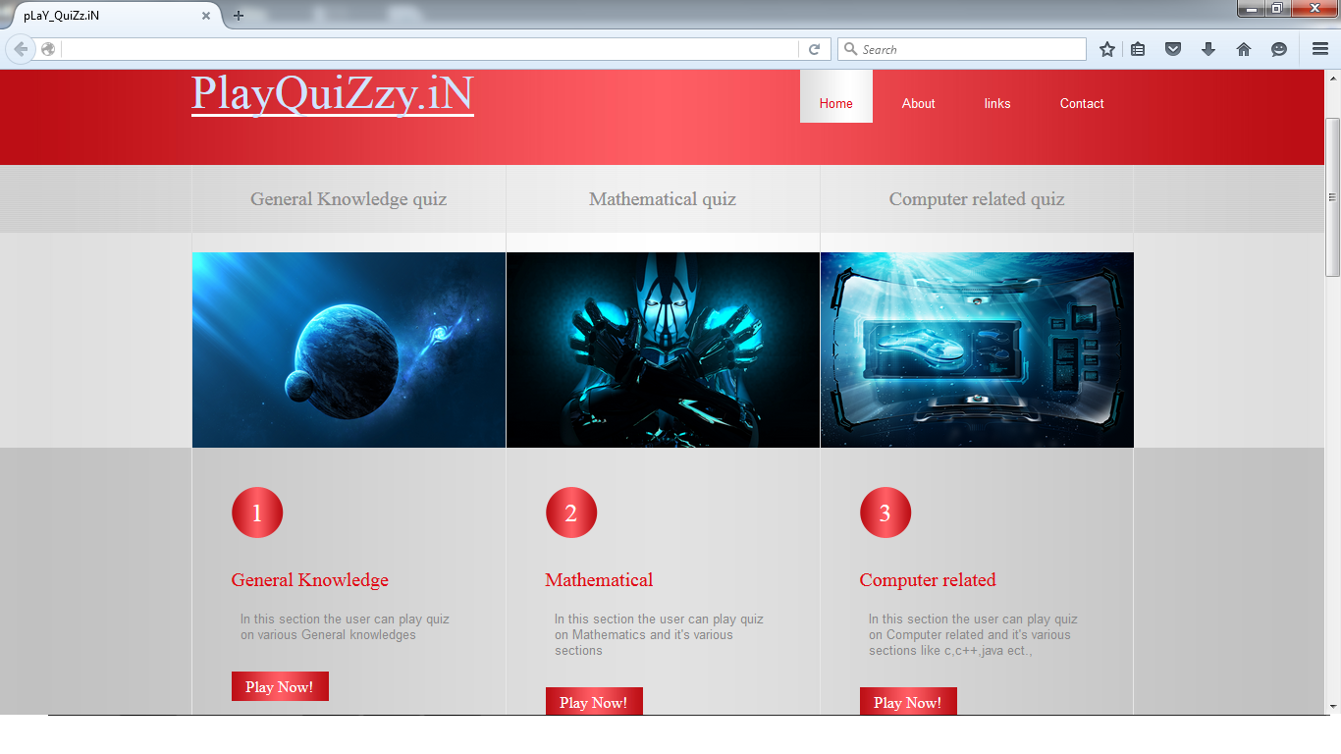
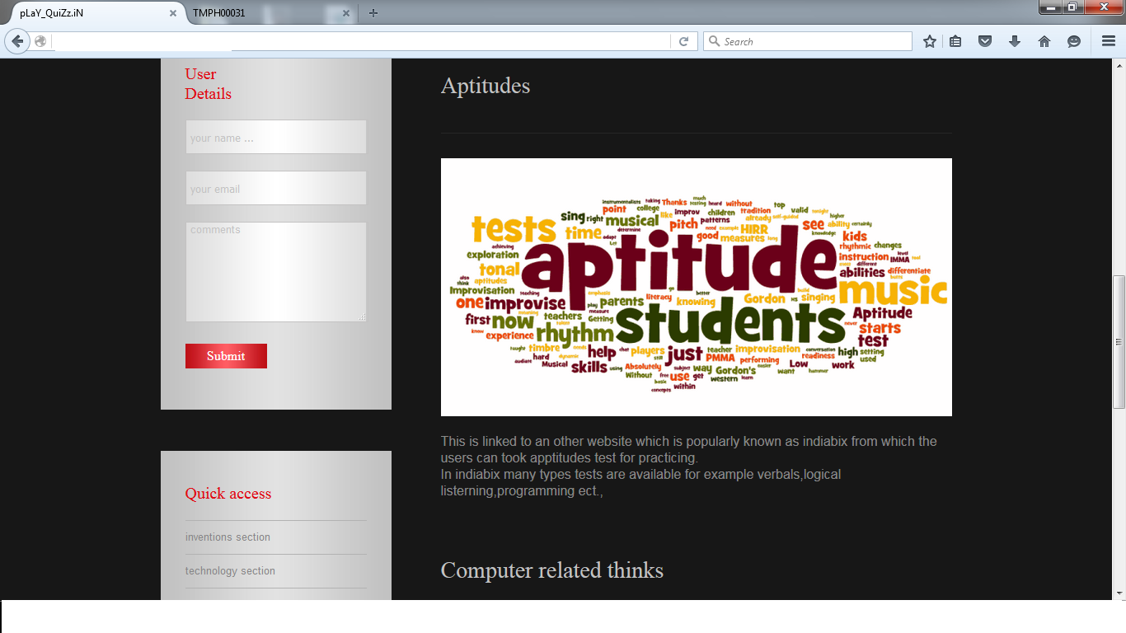
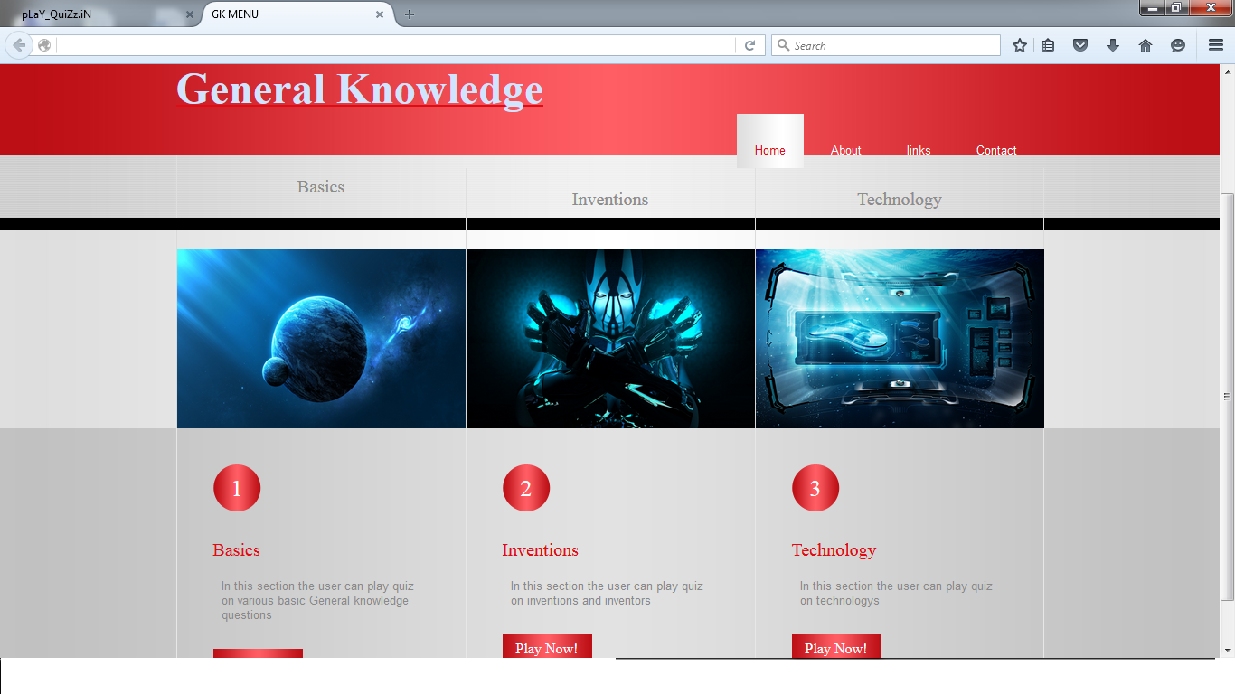
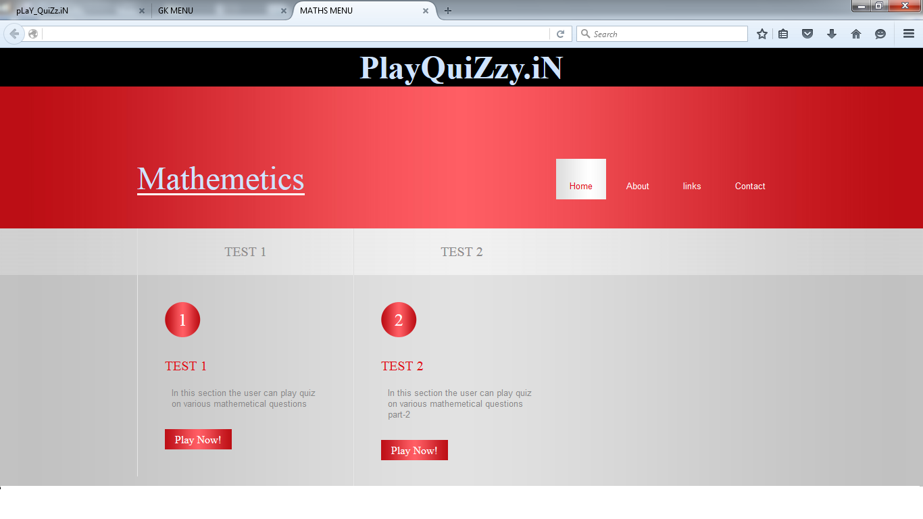
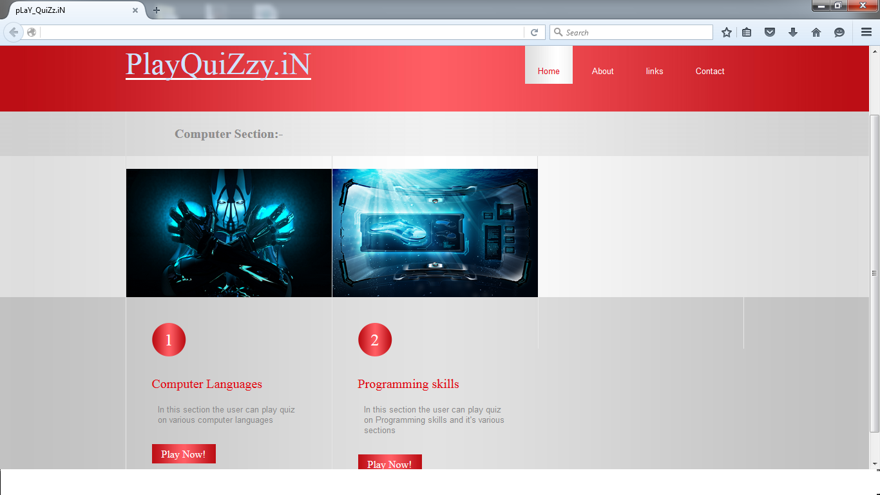
Like this page all questions are set with a timer for different categories or sections :

